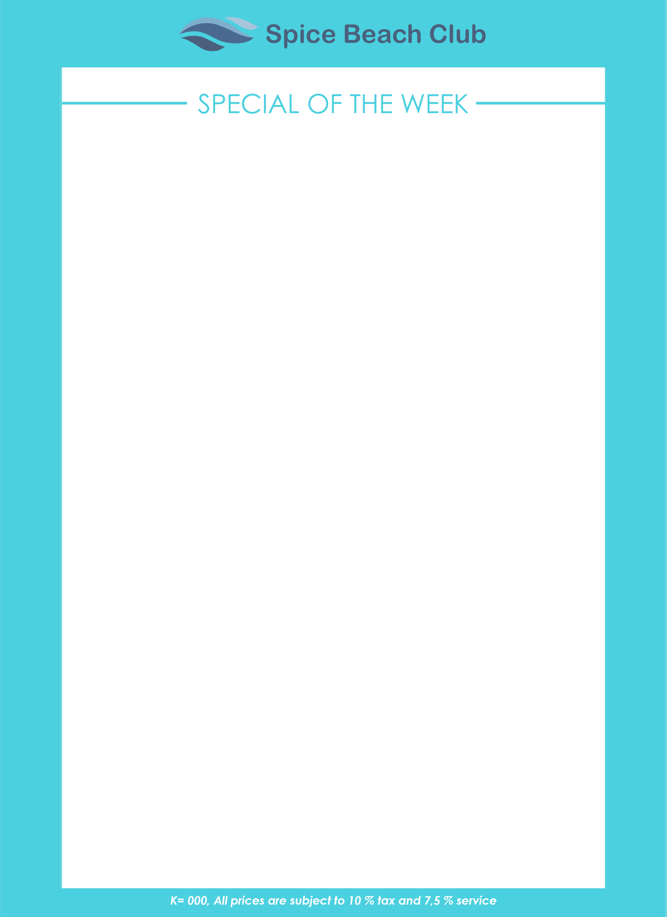

**Palm Living Tour**

**- STARTER -**

***(Choice of ) :***

* **Mix Salad**

(Mesclum,Tomatoes,Cucumber, Colourful Paprika ,Choice dressing 1000 island/blue cheese/olive oil/vinegar

* **SEAFOOD SPRING ROLL**

(Stuffed with Prawns, Tuna, Squid & Vegetables, Sweet & Sour sc.)

**- MAIN COURSE -**

***(Choice of ) :***

* **GRILLED TUNA SAMBAL MATAH**

(Marinated Grilled Tuna, Balinese Vegetables, Steam Rice & Crackers)

* **Chicken Gordon Blue**

(Chicken Roiled with Ham & Cheedar slide of Mixed Vegetables & French Fries )

* **NASI GORENG VEGETABLES**

(Fried Rice Vegetables, served with Fried Egg)

**- DESSERT -**

***(Choice of ) :***

* **FRESH FRUITS PLATTER**

***DRINKS***

***(Choice of ) : 1. Mineral water***

***2. Juice /Soft Drinks***

**SET MENU LUNCH**